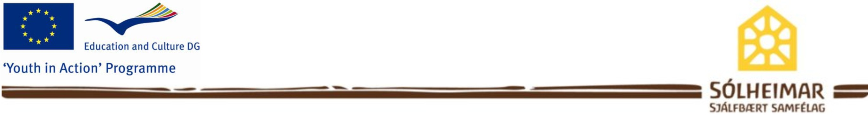

Picture
Sólheimar EVS Project
Sólheimar Volunteer Application

Please fill out this application and return it via
Email internship@solheimar.is (in Microsoft Word format).

Name:
Date of Birth:
Sex: Female / Male
Nationality:
Mailing Address:
Marital Status (optional):
Telephone:
Email:

- I am applying for the following sub-projects (Mark with numbers 1-3 projects in order of interest and preference). All projects are explained in the “Sólheimar EVS Voluntary Project - Information document”
x
Sesseljuhús – environmental sustainability
x
Tree Nursery - Forestry
x
Organic Horticulture.
x
Nærandi – Food production and Bakery
Service learning. (Coffee shop)
x
Art workshop. (Weaving, textiles, painting, ceramics, organic soap-making candle-making, woodwork).
x
x
Maintenance and Carpentry.
(Application deadline is 1st January 2013, and the project start
1st September 2013)
Note: We are only looking for a long term EVS volunteers for 12 months. However if you like to come to Solheimar and stay for shorter period please check out our internship programme.

- What is the name and EI Ref of your EVS Sending Organization? ProAtlântico – Associação Juvenil (2010-PT-28)

- Please list your work experiences (beginning with the most recent):

- Describe your educational background (beginning with the most recent). Please include any special training or certification, and/or the specific area of study you are focusing on.

- What is your native language? Do you have any foreign language skills?

Short Answers (8 questions): Please respond to these questions in a thoughtful paragraph or two.

- What are your reasons for applying to the Sólheimar Voluntary Project? What attracts you to Sólheimar?

- What do you foresee as being a challenging aspect of the Sólheimar Volunteering experience? How do you see yourself working with these challenges?

- What does the concept of community mean to you?

- Please describe any international experiences, or ways in which you were asked to extend beyond your own culture. What have you learned from these experiences?

- In your own words, define “sustainability” and describe what a sustainable community means to you.

- Please include any other details about yourself (do you play an instrument? passions, hobbies, educational goals, group-working experiences, aspirations, interesting facts, etc.).

Essay Component (1 Essay)

- Please describe your learning goals for your stay in Sólheimar in a brief essay (500 words or less). This should include the specific project-area you want to focus on with an emphasis on your learning goals and educational background/experiences that would help you attain these goals. Why are you choosing the project(s) in question 1 above and how do you think that your knowledge or skills can be useful in the project?

If you have a CV (EVS, Euro pass or other) and motivation letter (EVS, Euro pass or other), please send it with your application.

